CIF the Netherlands

CIF The Netherlands’ International Professional Exchange Program 2018
with special focus on “Social Inclusion in Deprived Neighborhoods”
for Professionals from the Field of Social Work / Human Services

28 September – 12 October 2019

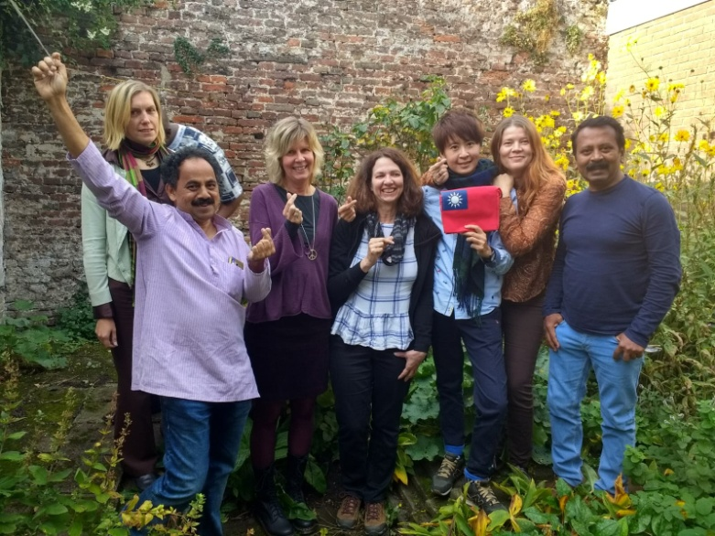

CIF The Netherlands invites Professionals from the Field of Social Work / Human Services to apply for its 32nd Exchange Program which will be held from 28 September to 12 October 2019.

The “International Professional Exchange Program” is organized by CIF The Netherlands in close co-operation with the University of Applied Sciences, School of Social Work and Law in Amsterdam.

The purpose of the Council of International Fellowship (CIF Int.) of which CIF The Netherlands is a member, is to promote professional, cross-cultural and educational exchange for those working in the field of social services. The learning and sharing generated by these exchanges provide opportunities for broadening professional as well as personal development and so contribute to peace and understanding. The program combines practical and theoretical information about the social and cultural environment. Cross-cultural exchange is a crucial part of the program as participants come from different countries.

The present changes and challenges in the social field provide a unique opportunity to look at innovative methods to offer a suitable array of services usually centered in the neighborhoods to citizens who are unable to fully participate in society on their own. These ideas about reaching out to people are set in the present social and political reality of the Netherlands. Therefore the theme of the program will be “Social Inclusion in Deprived Neighborhoods”. It will give a unique chance to experience both the theoretical and practical side of this approach and relate it to one’s specific field of work.

The program is divided in a ‘general program’ from 29 September to 5 October and an ‘individual program’ from 5 - 12 October.
The ‘general program’ for all participants is organized by the School of Social Work and takes place in Amsterdam. The participants will be introduced to different aspects of “Social Inclusion”. They meet and interact with students, follow some lectures and visit organizations working with this approach. The participants will be asked to relate this approach to their own work, or the organization they work for. They will also be interacting with students sharing their professional/work experiences in an international perspective.

As accommodation is shared, the participants will have an excellent opportunity to get to know and support each other, to exchange views and experiences and to explore the city of Amsterdam.

During the ‘individual program’, organized by CIF coordinators, the participants will be placed in different parts of the country and get an exposure to different agencies in the field of work chosen by the participant. All set against the changes that take place in our care system, which is asking a lot of the professionals and volunteers that are part of our system.

Participants will stay and interact with host families, a great way to learn more about the culture of the Netherlands.

Please note that it is not possible to actually work in the agencies.

Language: The working language is English which the participant has to master sufficiently to be able to participate and gain fully.

Number of Participants: CIF Netherlands will select 5-8 participants. In case there are applications for the same kind of work related experience / professional background, they will be grouped together to maximize the opportunity to learn from the visits to the agencies as well as from each other.

Financial conditions: The participant’s fee is € 350. They are used to cover part of the costs related to the organization of the program, including accommodation in Amsterdam. The participants will be requested to pay the fees after selection as part of their confirmation of participation.
Please note that no grants can be provided to participants. Visa (when needed) and travel costs to and from the country are for the participant.

Support: Accommodation will be provided during the whole period, in the form of shared apartment housing in Amsterdam and host family living during the individual program.

Applications: The applications need to go through the CIF National Branch (NB) or Contact Person (CP) in your country, using the international application form. The National Branch or Contact Person will sent your application together with their recommendation to us. Addresses of NBs and CPs can be found on the CIF International website: www.cifinternational.com under organization. When there is no CIF Branch or CP in your country, you can contact CIF Netherlands directly. The application form can be downloaded from the CIF International website: http://www.cifinternational.com under programs/how to apply.

The application and recommendation letter have to reach us not later than 1 April 2019 at info@cifnetherlands.nl. You will receive confirmation of receipt.

More information about CIF International, its National Branches and Programs www.cifinternational.com

